**P6.67 Double-Sided Outdoor Cross Display Setup**

**General Information:**

There are 8 sets of double-sided of P6.67 Cross LED displays in this order. Each set includes 10 modules of both faces, 1 TB2 WiFi card, 1 Receiving Card, 4 power supplies.

1. **Module Layout**

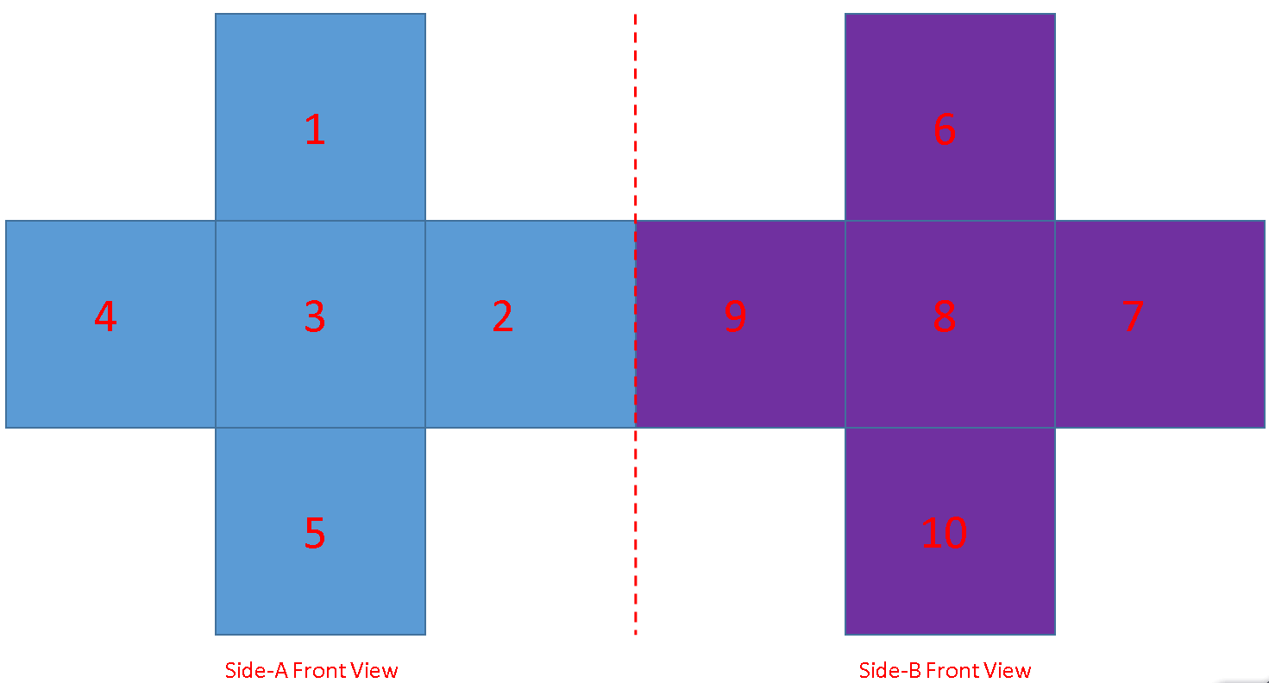

1. **Cable Connection**
2. DC 5V Power Cable

1 PSU can supply 3 Modules.

Please connect both DC5V cable on each module for sufficient supply.

1. Flat Cables.

2 Kinds of Flat cables are included. The longer cable is from Receiving Card to Modules. The shorter one is from module to module.

According to above module layout of each side, run the flat cables from receiving card to modules, and from modules to modules accordingly. Please follow below table to connect the cables on corresponding connectors:

|  |  |  |  |  |  |  |  |  |  |  |  |  |  |  |  |  |  |  |  |  |
| --- | --- | --- | --- | --- | --- | --- | --- | --- | --- | --- | --- | --- | --- | --- | --- | --- | --- | --- | --- | --- |
| |  |  |  | | --- | --- | --- | | **Longer Flat Cable Connections (Receiving Card - Module)** | | | |  | **Receiving Card** | **Module-Connector** | | **Side A** | **JP1** | **1-IN** | | **JP2** | **2-IN** | | **JP3** | **5-IN** | | **Side B** | **JP4** | **6-IN** | | **JP5** | **7-IN** | | **JP6** | **10-IN** | |

|  |  |  |  |  |
| --- | --- | --- | --- | --- |
| **Shorter Flat Cable Connections (Module - Module)** | | | | |
|  | **Module-Connector** | | **Module-Connector** | |
| **Side A** | **2-OUT** | **3-IN** | **3-OUT** | **4-IN** |
| **Side B** | **7-OUT** | **8-IN** | **8-OUT** | **9-IN** |

1. Net Cable

Connect Net Cable from WiFi Card “LED Out” to Receiving Card

1. **Operation**

The 2 sides of the display can be considered as a whole screen, 288x144 pixels. If the same content is expected to display on both sides, the screen can be divided into 2 windows when making programs.